Caritas Australia’s Gaza Crisis Appeal
An estimated 1 million people have been displaced in Gaza with immediate food, shelter, health, and psychosocial needs.

‘This is a period of incredible turmoil and sadness. The escalation of violence has only exacerbated needs for the people in Gaza and West Bank, who already live in dire conditions. We are working with our partners on the ground to provide comprehensive and critical support to over 17,000 families affected by this devastating conflict.’
Sally Thomas, Humanitarian Lead, Caritas Australia

With your support, we will be able to help our partners on the ground to assist people displaced and affected by the current conflict.

Please donate to Caritas Australia’s Gaza Crisis Appeal.
You can donate online www.caritas.org.au/gaza or phone 1800 024 413

QR Code | Image
 | 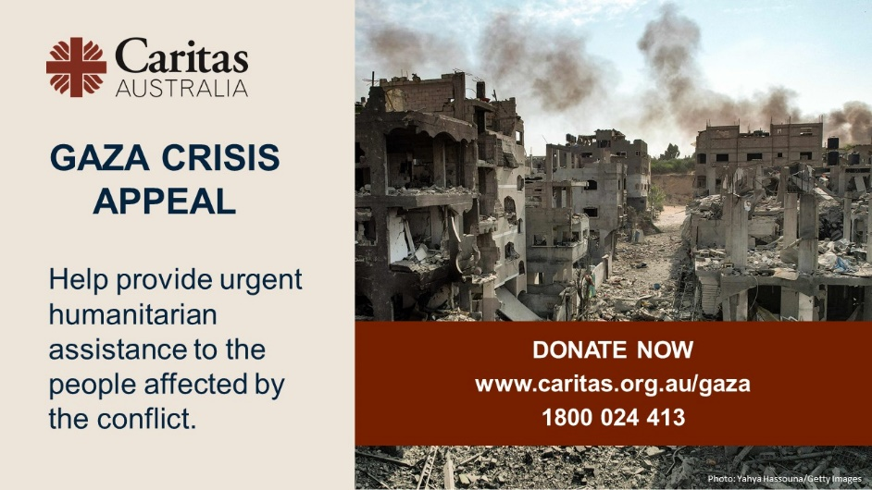

An Urgent Prayer for Peace
God of compassion,
We turn to you with heavy hearts
As we consider the needs of your family.
Israelis and Palestinians, we are all your people,
Each of us loved by You
And called to live in peace and justice.
We lament the dreadful loss of life,
Destruction of property and loss of human dignity.
We are pained by so much suffering.
We beg you to bring healing to this ancient place.
Help your people find a way forward.
Enable everyone to look each other in the eye,
And embrace each other as sisters and brothers,
As they find your image in every face.
We ask that courage and grace
Will help create a wiser and more gentle future,
Where everyone has a home.
God of wisdom, come to our aid.
Amen.

By Michael McGirr / Caritas Australia

