

|  |
| --- |
| Secondary School Immunisation Program |
| **Sample Secondary School Immunisation Program newsletter item for Term 4**  **2024** |
|  |

# **Missed school vaccinations 2024**

# Key messages for parents/guardians

* The Secondary School Immunisation Program offers free vaccines provided by the [National Immunisation Program](https://www.health.gov.au/health-topics/immunisation/when-to-get-vaccinated/national-immunisation-program-schedule) each year to students in Year 7 (HPV and Diphtheria/Tetanus/Whooping cough) and Year 10 (Meningococcal ACWY).
* If your child missed out on receiving their vaccinations at school this year, it's not too late to get vaccinated.
* Free adolescent vaccines can be accessed at your local council immunisation service, GP or pharmacist immuniser.
* To see if your child is due for any vaccines, check your child’s [immunisation history statement](https://www.servicesaustralia.gov.au/how-to-get-immunisation-history-statement?context=22436) on the Australian Immunisation Register using your [MyGov account](https://my.gov.au/). Children aged 14 years of age and over can access their own immunisation history statement via MyGov.

# Further information

* Contact the local council immunisation provider [insert contact details]
* Better Health Channel – Secondary School Immunisation Program fact sheet - <https://www.betterhealth.vic.gov.au/health/healthyliving/immunisation-in-secondary-schools>
* Adolescent vaccinations outside of school and catch-up immunisation – <https://www.health.vic.gov.au/immunisation/adolescent-vaccinations-outside-of-school-and-catch-up-immunisation>

Image for use in school communications Term 4 - 2024

* Social Media Pack – Secondary School Immunisation Program (download section) - <https://www.health.vic.gov.au/immunisation/secondary-school-immunisation-program>

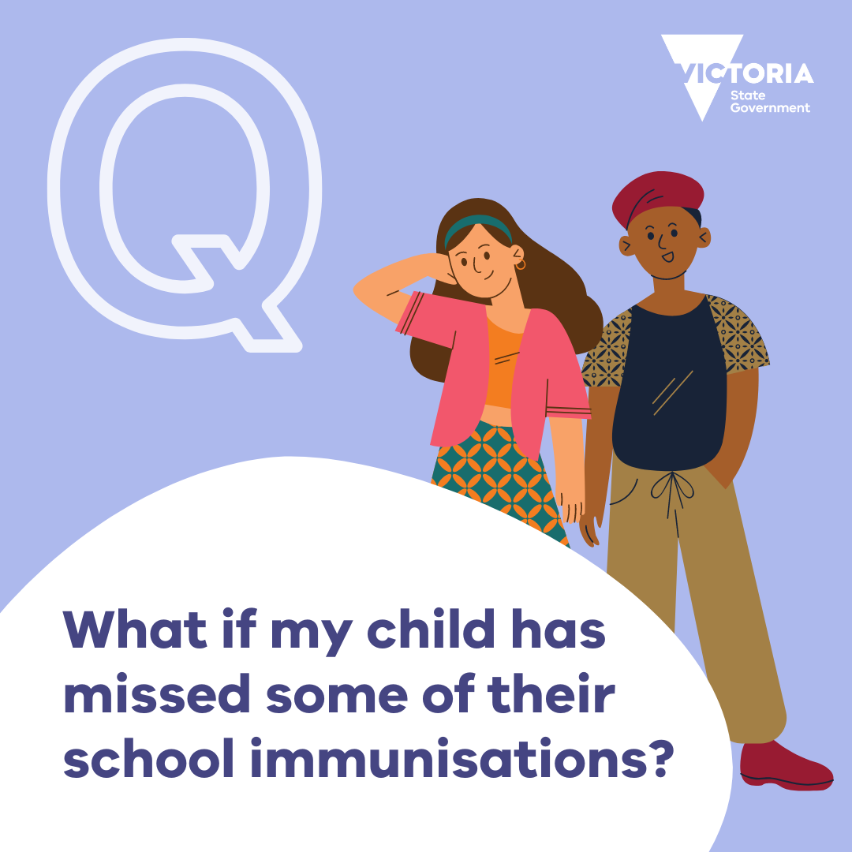

|  |
| --- |
| To receive this document in another format, email the [Immunisation Program](mailto:imunisation@health.vic.gov.au)<immunisation@health.vic.gov.au>  Authorised and published by the Victorian Government, 1 Treasury Place, Melbourne.© State of Victoria, Australia, Department of Health, October 2024. |