**Thunderstorm Asthma – be prepared this pollen season**

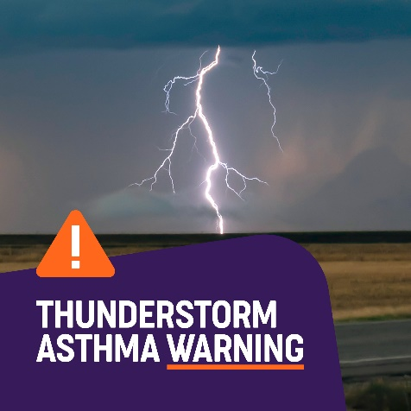

**What is Thunderstorm Asthma?**

Thunderstorm asthma is a serious and potentially life-threatening phenomenon that can occur during specific weather conditions. It is common throughout all parts of Victoria, particularly during spring when thunderstorms coincide with high levels of pollen in the air.

This combination can trigger severe asthma symptoms, even in people who have not previously experienced asthma or allergies.

Epidemic thunderstorm asthma events are uncommon and don't occur every year. In south-east Australia they can happen during grass pollen season from October through December.

**What Causes Thunderstorm Asthma?**

During a thunderstorm, pollen grains can be swept up into the clouds, where they break into smaller particles due to moisture. These tiny particles then get blown down by the winds and spread across a wide area. Because they are so small, they can be easily inhaled, reaching deep into the lungs and triggering asthma symptoms such as wheezing, shortness of breath, and chest tightness.

**Preparing for Thunderstorm Asthma**

* **Stay Informed**: Keep track of pollen forecasts and thunderstorm warnings from the Bureau of Meteorology and the VicEmergency app.

**Check the epidemic thunderstorm asthma risk forecast**: Epidemic thunderstorm asthma risk forecasts in Victoria are available from 1 October to 31 December (the typical grass pollen season).

Download the Vic Emergency app from [**Google Play**](https://play.google.com/store/apps/details?id=com.naturallybeing.fireready&hl=en) or the [**App Store**](https://itunes.apple.com/au/app/vicemergency/id356559665?mt=8) and set up a 'watch zone' for your school location to make sure you are notified of the risk of an epidemic thunderstorm asthma event occurring. You can also visit the [**Vic Emergency thunderstorm asthma webpage**](http://www.emergency.vic.gov.au/prepare/#thunderstorm-asthma-forecast) for updates and information.

* **Have Asthma Action Plans**: Ensure that students with known asthma have an up-to-date asthma action plan, and make sure staff are trained in asthma first aid.
* **Indoor Safety**: On high-risk days, consider holding activities indoors to minimise exposure to allergenic particles.

Schools should have staff trained in asthma first aid, and DOBCEL will monitor the VicEmergency app to receive thunderstorm warnings and notify schools, and when appropriate, students should be kept indoors when weather forecasts identify greater risk.

By raising awareness and being prepared, schools can protect their students and staff from the risks associated with thunderstorm asthma, ensuring a safer environment for everyone.

**Find out more**

Further information regarding thunderstorm asthma can be found at <https://asthma.org.au/triggers/thunderstorm-asthma/> and <https://www.health.vic.gov.au/environmental-health/epidemic-thunderstorm-asthma-risk-forecast>.