

In reply please quote:

VCEA- CM Doc No

6 September 2024

Circular to principals of Catholic schools in Victoria

**School Saving Bonus information for schools and parents**

**Main Points**

* The Victorian Government has provided the Victorian Catholic Education Authority (VCEA) with initial information about the School Saving Bonus (SSB) process for non-government school students.
* Non-government school students receiving the means-tested Camps, Sports and Excursions Fund (CSEF) are eligible for the Victorian Government’s $400 SSB.
* There is no separate application process for non-government school students to receive the SSB. Payments for eligible non-government students will be made directly to the student’s school in November 2024, for eligible students expected to remain at the school in 2025. The Department of Education will email you with further information around this time.
* Additional SSB payments will be made to schools in 2025, for eligible students new to the school in 2025, after schools submit the required information to the Department of Education.
* SSB payments are to be managed in consultation with the eligible student’s family.

**Critical Dates**

* SSB payments will begin to be made to schools by the Department of Education in November 2024, with further payments in 2025 for eligible students new to schools in 2025.

|  |
| --- |
| **Actions Required**   * Schools are encouraged to contact the parents and carers of eligible students and discuss their family’s needs prior to the SSB being received by the school. * Please also share this [letter from the Premier and Minister for Education](https://cevn.cecv.catholic.edu.au/Melb/Document-File/vcea/Additional-updates/SSB_letter_non-government_schools.pdf) with the parents and carers of eligible students. This letter will be available to download in 14 languages from the Department of Education’s [website](https://www.vic.gov.au/school-saving-bonus) in the next few weeks. |

**Additional Information**

* Eligible families who have more than one child at the same school can combine their SSB payments to use on one child, or for a specific activity. For example, a family with 3 eligible children will receive support to the value of $1,200.
* Parents of eligible students are encouraged to discuss their needs with their school prior to the SSB being distributed.
* Unused money from the SSB can be transferred to a sibling at the same school if one child finishes school.
* The SSB cannot be combined across different schools, and cannot be transferred between government and non-government schools.
* The one-off SSB will be in addition to existing and continuing means-tested supports for the CSEF.

**Contact/Enquiries**

* For more information on the SSB, please visit the Department of Education’s [website](https://www.vic.gov.au/school-saving-bonus) or email [school.saving.bonus@education.vic.gov.au](mailto:school.saving.bonus@education.vic.gov.au).

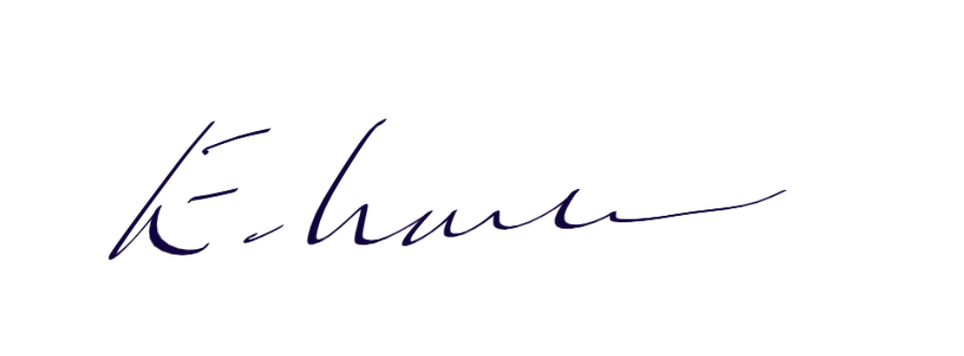

Professor Elizabeth Labone

Chief Executive Officer