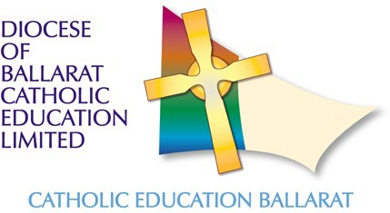

**Expressions of interest (EOI) for 2025: Pathways to Principalship – The Brown Collective**

**8-month program (commencing approx. March 2026)**

**Program Overview**

Expressions of interest are currently being taken for a 2026 cohort of Pathways to School Leadership. This program aims to support the ongoing development of school leadership.

Providing the opportunity for deep reflection on your practices and the opportunity to complete a 360-degree survey, participants will be provided with executive coaching to develop leadership skills around leading self, leading teams, and leading change. The program will develop key strategic intentions such as deeper collaboration and innovation and provide the opportunity to collaborate with others on rich pedagogical practices for deeper learning and wellbeing.

*There must be a minimum of 15 confirmed participants for the program to run in 2026.*

**Target Audience** - New Principals, Deputy or Assistant Principals, aspiring principals, and members of school leadership teams.

**Cost** – $3500 plus any travel and expenses.

To submit an expression of interest, please click [here](https://docs.google.com/forms/d/e/1FAIpQLSfa3SfnlH3YYFd2TgZuaJY_WqsfM8Mgc_eRQWgyrKqXK5XNYA/viewform?usp=sf_link" \t "_blank)

*Expressions of interest are due by Friday, 19 September 2025, with program confirmation occurring in term 4, 2025.*

Any enquiries, please contact: [Fiona Murphy](mailto:fmurphy@dobcel.catholic.edu.au)