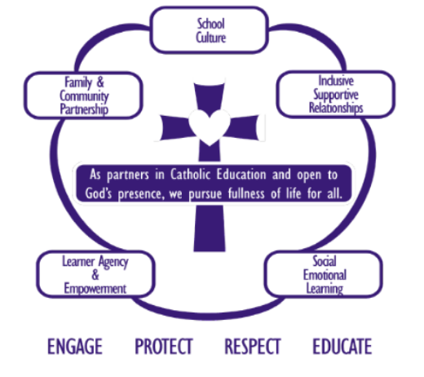
SWPBS – Information - Session
Does your Insight SRC data highlight areas for improvement in student management, staff stress levels, and student wellbeing? Have student safety and behaviour been identified as priorities for 2026?
Many of our schools are recognising the need for a more structured, evidence-based approach to student wellbeing and behaviour.
As part of our renewed school improvement model, we are refreshing our School-Wide Positive Behaviour Support (SWPBS) with new and improved, well researched supporting material to guide schools with implementation.

SWPBS framework provides clear structures and targeted support to enhance the learning environment for all students.
What is SWPBS?
School-Wide Positive Behaviour Support (SWPBS) is a whole-school framework designed to improve student behaviour, wellbeing, and academic performance. It is implemented across P–12 settings and focuses on:
Promoting positive behaviour

- Preventing problem behaviours before they escalate
- Creating safe, supportive, and inclusive learning environments
- Using data-driven decision-making and evidence-informed practices

SWPBS works best when there is a strong, school-wide commitment to consistent implementation. When embedded effectively, it not only reduces behavioural incidents but also supports staff wellbeing and strengthens school culture.

As we look toward 2026, prioritising student safety and behaviour through frameworks like SWPBS is essential for ensuring long-term, sustainable improvements in student outcomes and staff satisfaction.

Join us for a briefing Session on the 8th of October - Come and hear from other Principals who are implementing SWPBS

What would school commitment look like?
Supporting Schools in the Ballarat Diocese .docx

In person at the Horsham or Ballarat office 11.30 am – 1.00 pm Cuppa and question- RSVP to
Anne Ruddell – aruddell@ceob.edu.au Jane Bennett jbennett@ceob.edu.au

